**Cloud Computing :: Simple Vertulization**

Core Concept:

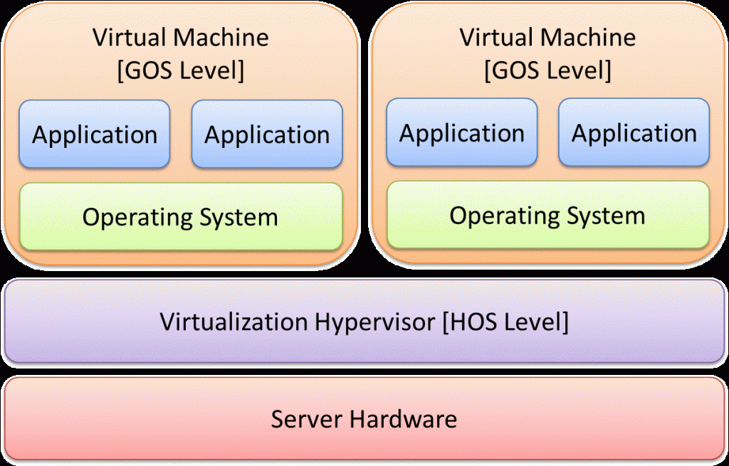

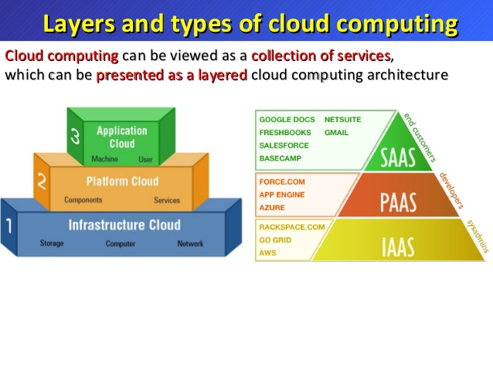

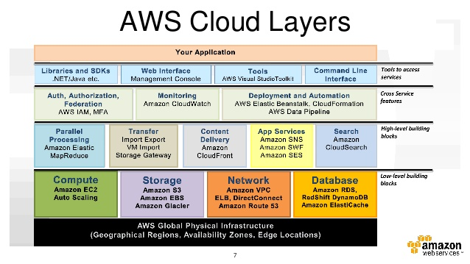

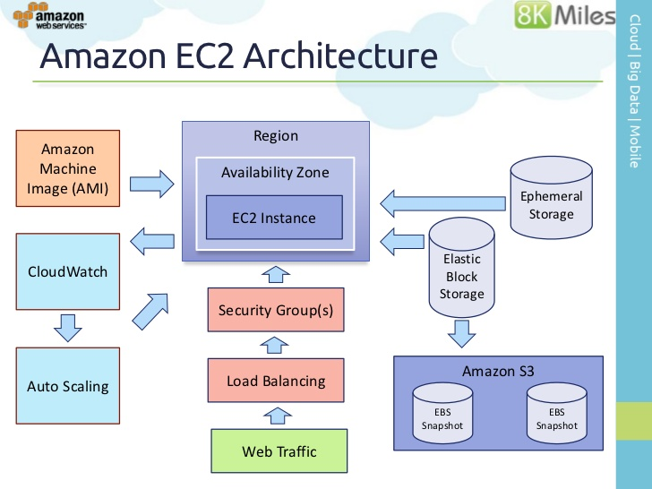

**Linux AMI Virtualization Types**

Linux Amazon Machine Images use one of two types of virtualization: paravirtual (PV) or hardware virtual machine (HVM). The main difference between PV and HVM AMIs is the way in which they boot and whether they can take advantage of special hardware extensions (CPU, network, and storage) for better performance.

**HVM AMIs**

HVM AMIs are presented with a fully virtualized set of hardware and boot by executing the master boot record of the root block device of your image. This virtualization type provides the ability to run an operating system directly on top of a virtual machine without any modification, as if it were run on the bare-metal hardware. The Amazon EC2 host system emulates some or all of the underlying hardware that is presented to the guest.

1. Login into AWS console and click on EC2

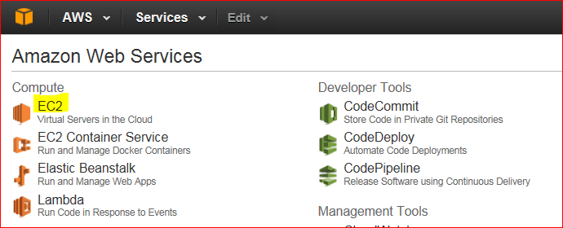

1. Click on Launch

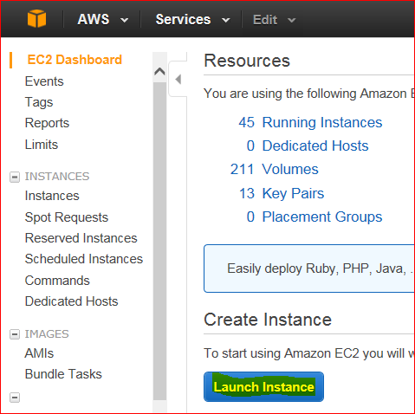

1. Select AMI image

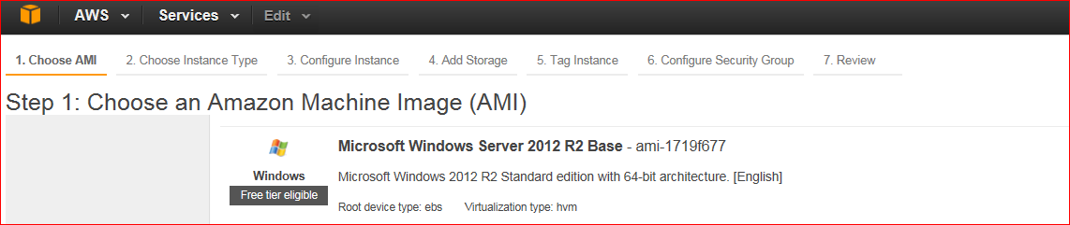

1. Choose instance type

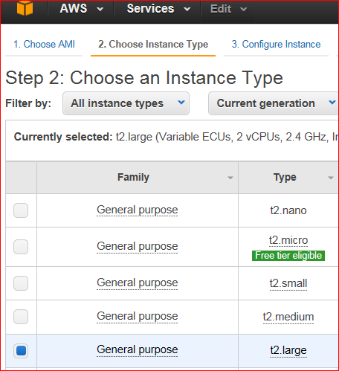

1. Configure network setting as per requirment.

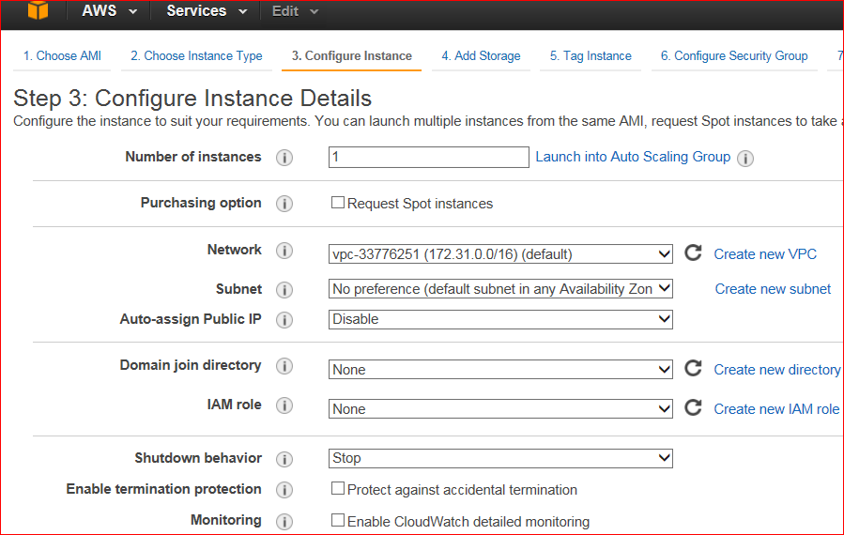

1. Add storage

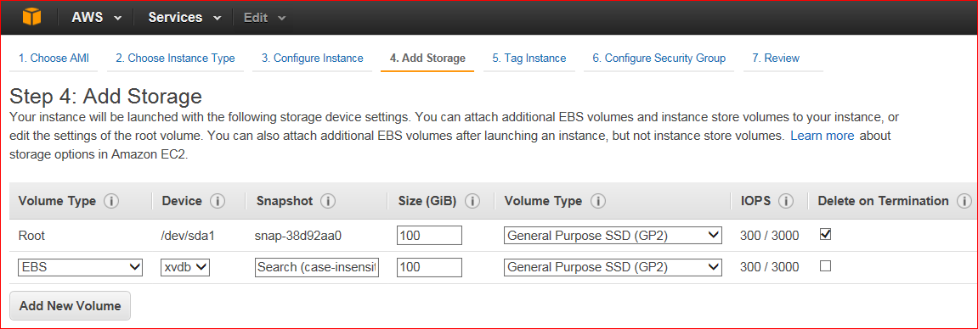

1. Tag Server

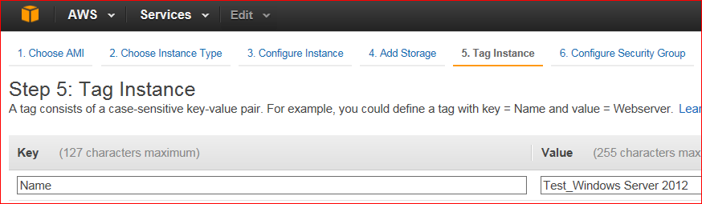

1. Here either select default security group or go with existing security group

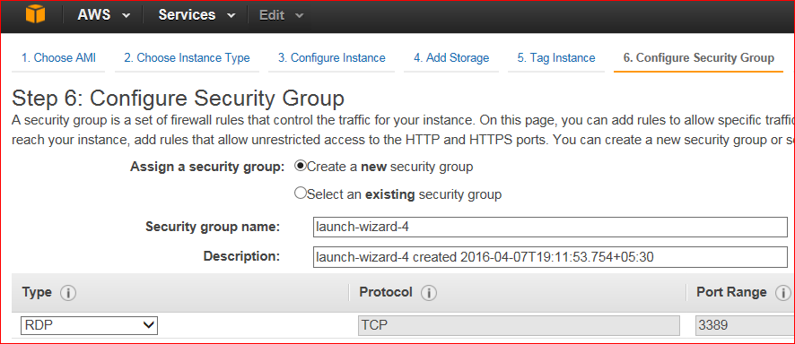

1. Review all setting and launch

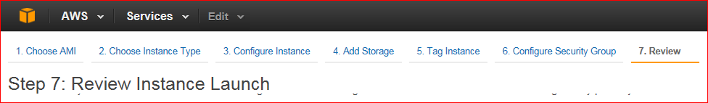

1. Select an existing key pair or create a new key pair. Launch instance

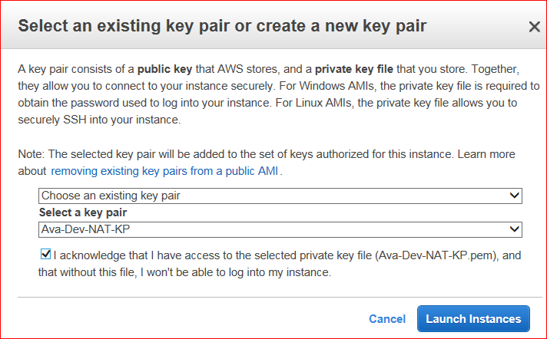

1. Finally you will see instance up and running.

